EE30121 Coursework Experiment Report

MG2124

Table of Contents

Experiment 1: 2

Exercise 1: 2

Exercise 2: 3

Experiment 2: 5

Exercise 1 5

Exercise 2 5

Exercise 3 6

Exercise 4: 8

Experiment 3: 10

Exercise 1: 10

Exercise2: 12

Exercise 3: 13

# Experiment 1:

## Exercise 1:

In exercise 1 the figure 1 was created as specified in the laboratory document in Cadence Virtuoso

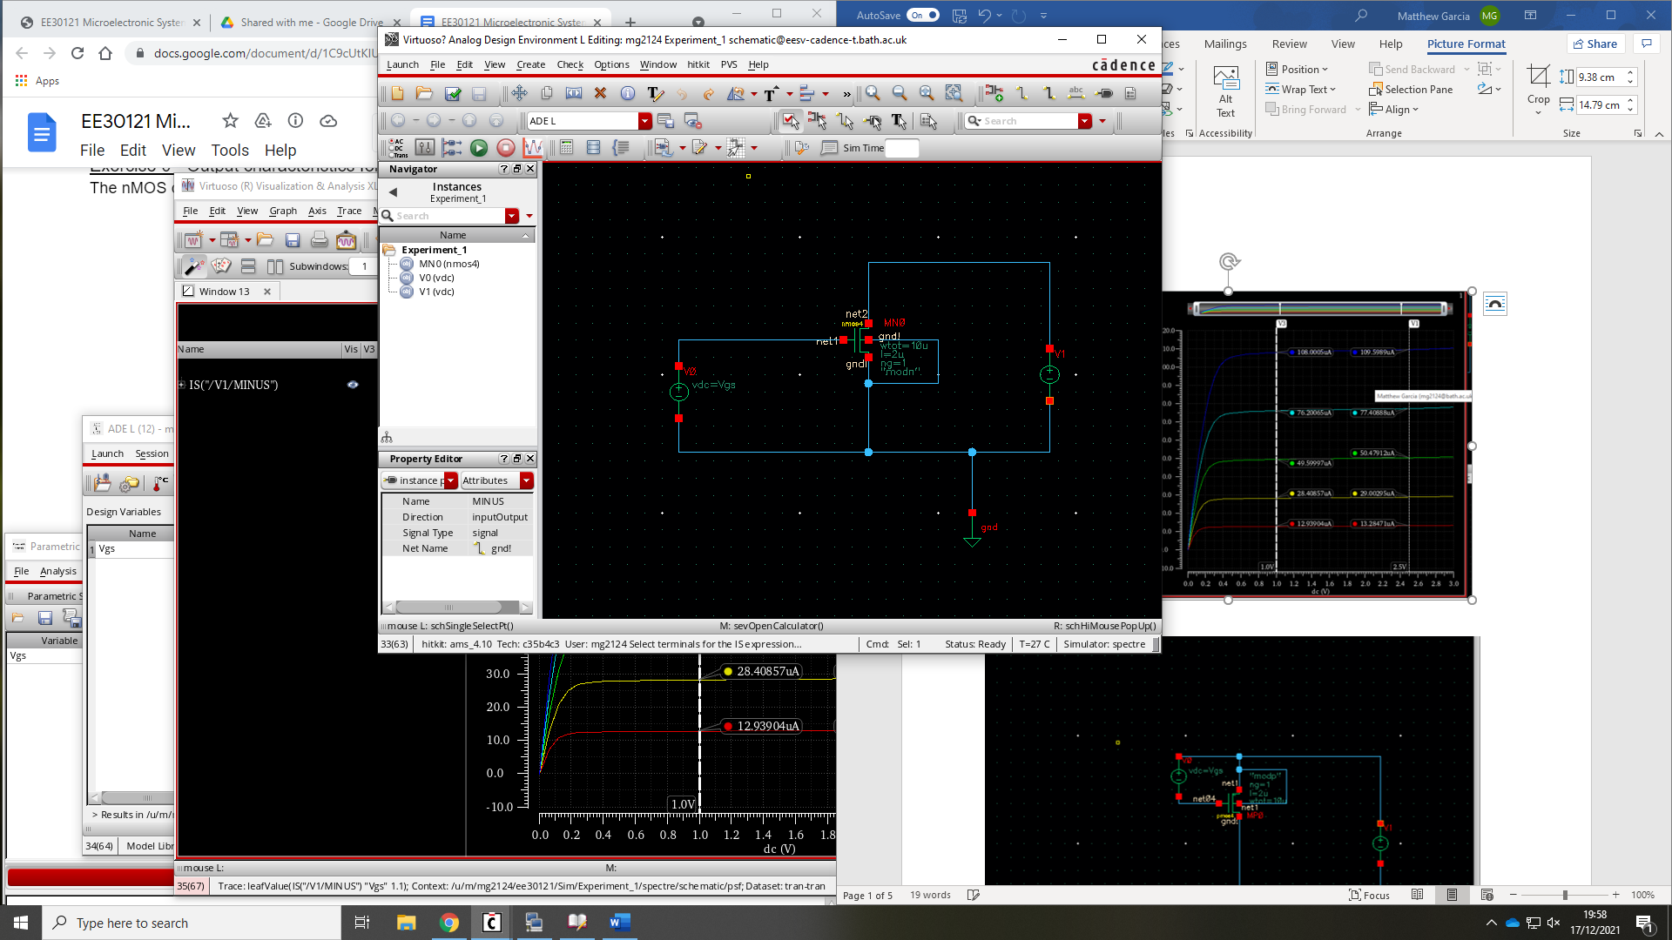

Figure 1: nmos characteristic circuit

Using the ADE L tool a DC analysis was using the operating point mode which varied the drain source voltage of the nmos V1 from 0-3. Using the parametric sweep the gate source voltage V0 is stepped from 0.7 to 1.1V, with a step size of 0.1V producing figure 2.

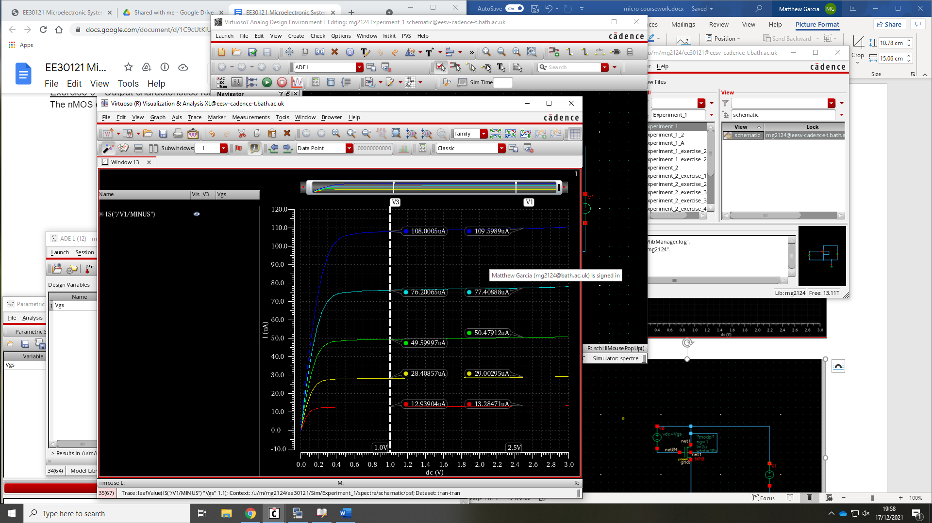

Figure 2: nmos Ids for varying Vgs

Using the figure 2 above the 1.1V plot was used by selecting the 2 points then apply them to the Shichman-Hodges equation $I_{D}=K\frac{W}{L}{\left(V_{GS}-V_{T}\right)}^{2}\left(1+λV_{DS}\right)$. $λ_{n}$ was calculated first and then sub backed into the above equation with one point to get $K_{n}$.

$$λ_{n}=9.962×{10}^{-3}$$

$$K_{n}=267.3×{10}^{-6}$$

This process was then repeated for the pmos schematic producing figure 4 and gave,

$$λ_{n}=0.01998$$

$$K_{n}=44.96×{10}^{-6}$$

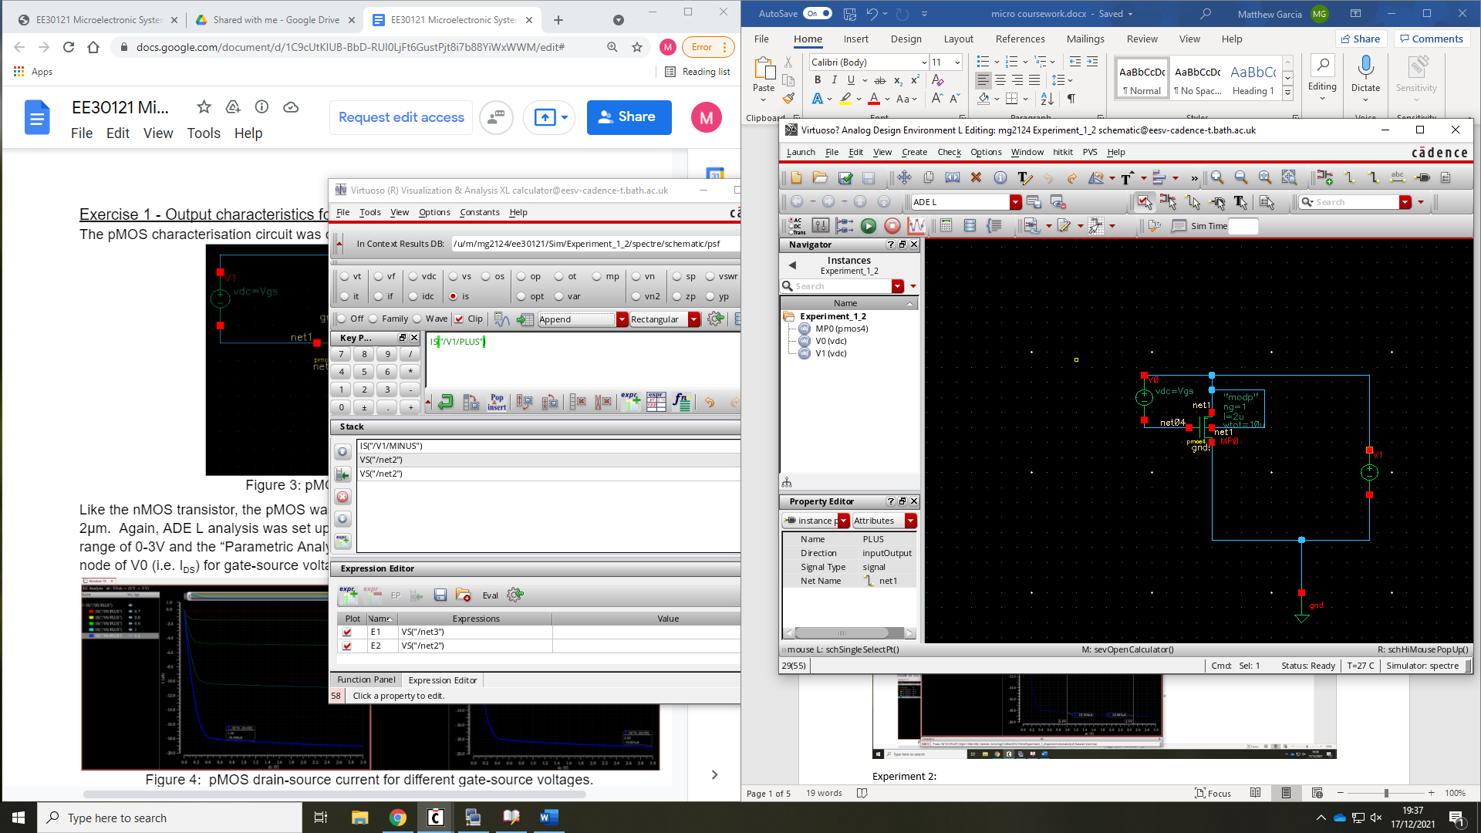

Figure 3: pmos characteristic circuit

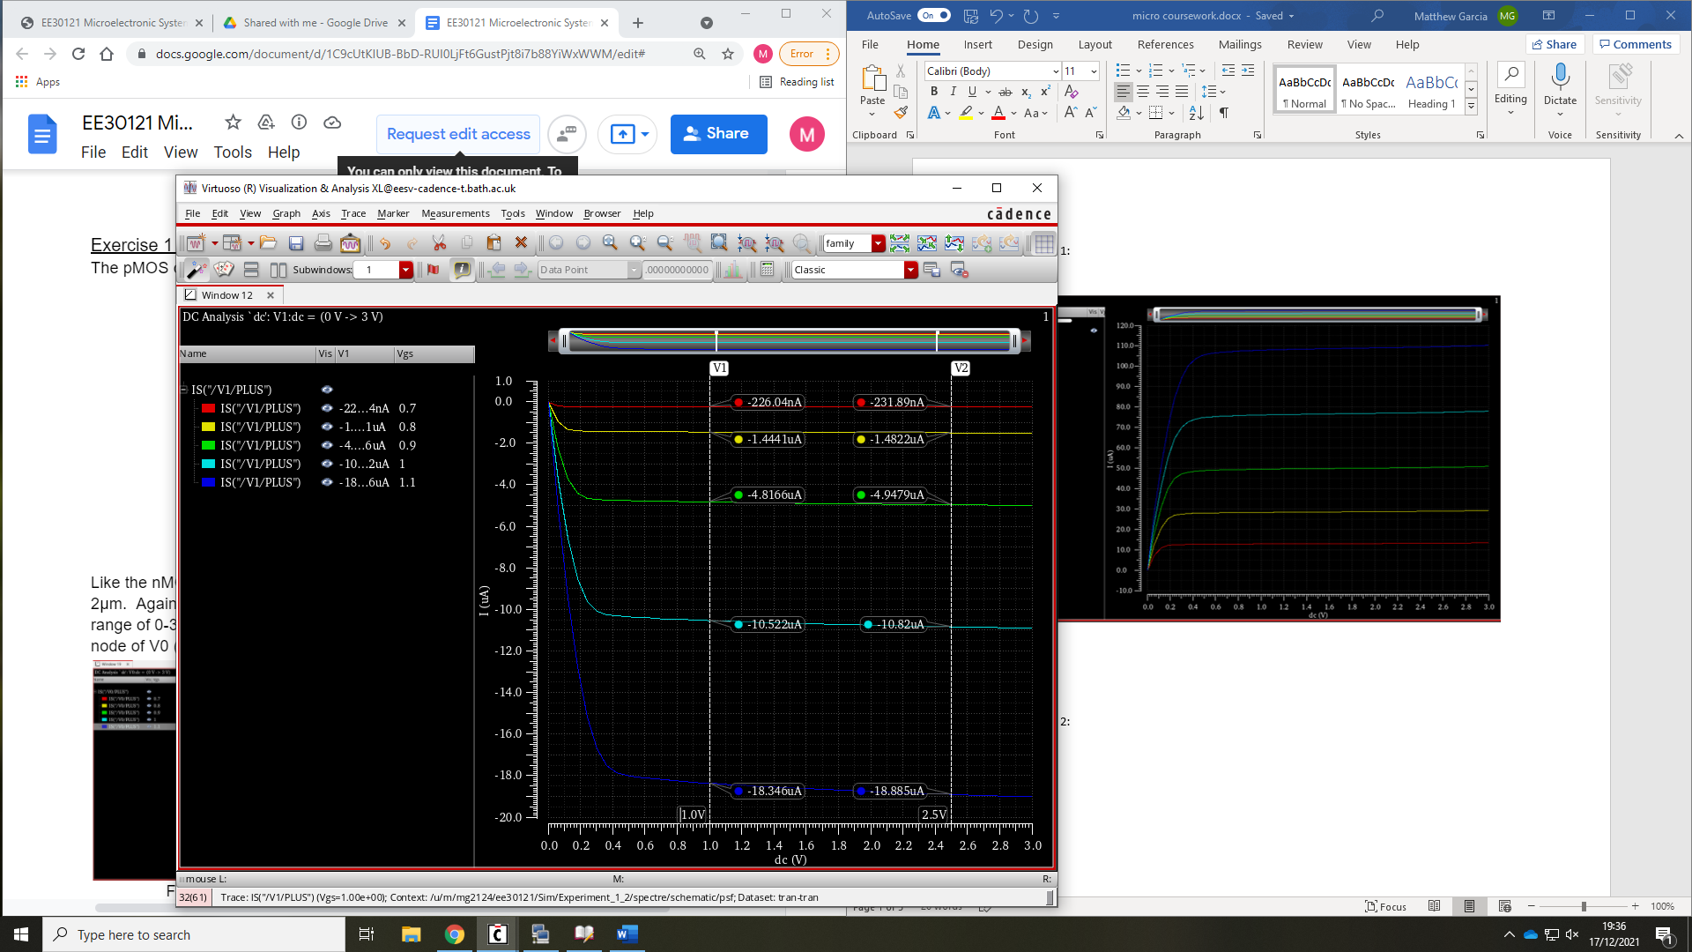

Figure 4: pmos Ids for varying Vgs

Comparing the two characteristics graphs, the pmos graph is the reflected version of the nmos about the voltage axis. This is to be expected as the pmos has a p-type substrate, current will therefore flow from the source to the drain when the voltage applied across the gate is negative, the current we measure will be negative in the pmos and positive in the nmos. Another effect of the pmos’s p-type substrate is when the voltage applied across the gate is negative the p substrate forms a channel of holes that flow as opposed to an electron flow channel. Electrons flow much faster than holes meaning if the same size mosfet is used the nmos will have a higher current. This is corroborated in figure_ with a difference in current magnitude.

## Exercise 2:

Figure 1 was used as the schematic to be simulated with the ADE L. This simulation was a DC operating point of Vgs from 0V to 3V and a parametric sweep was used for Vds from 0V to 3V with a step size of 0.5V. Using the inbuilt calculator function Ids and the derivative of Ids was plotted against Vgs producing figure_.

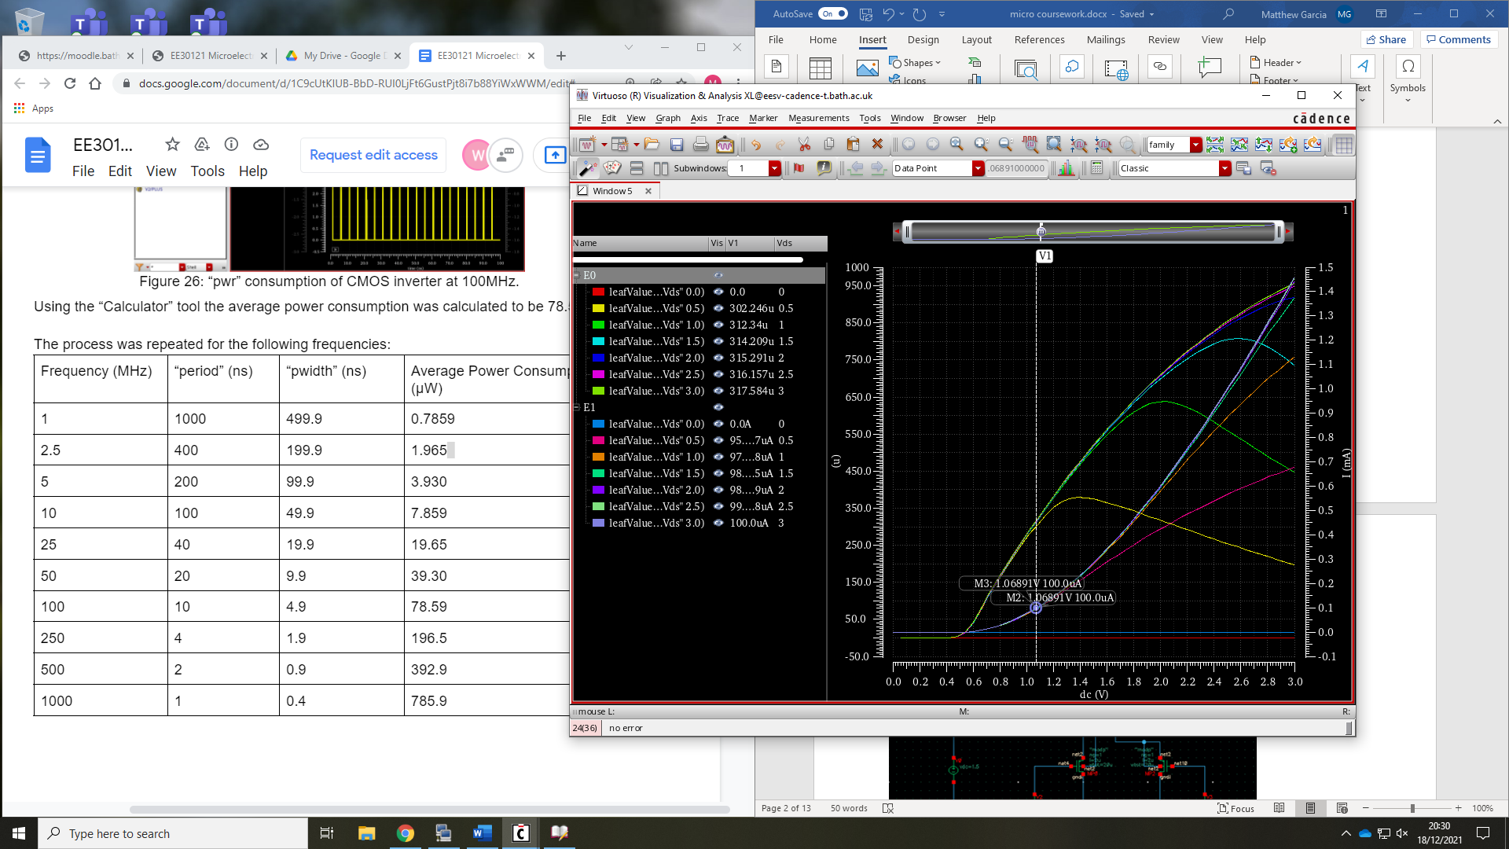

Figure 5: nmos transfer characteristics

In the figure 5 the derivative is the transconductance gain. To find the transconductance gain at 100 $μ$ A the two points in figure_ were taken to find the range of transcoductance gain between 0.5V to 3V

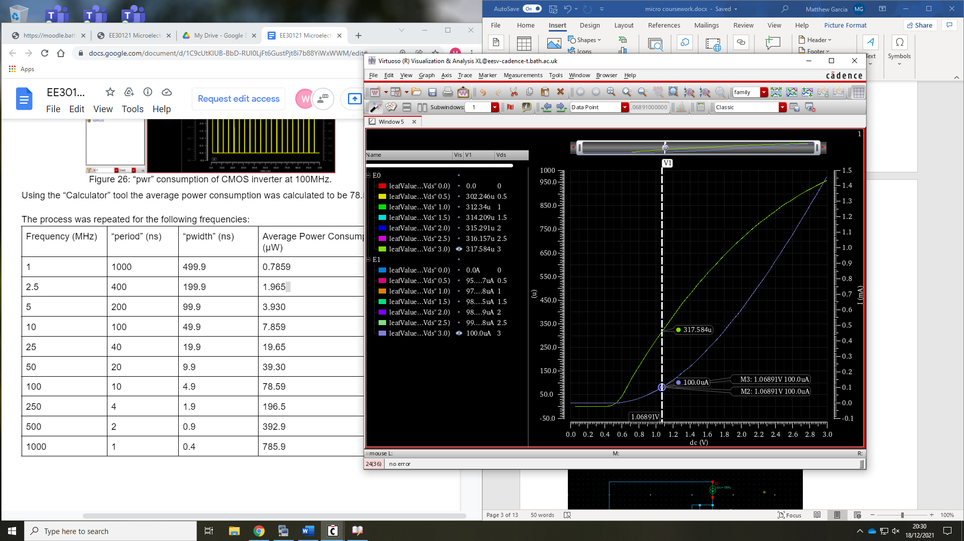

Figure 6: nmos transfer characteristics for Vds 3V

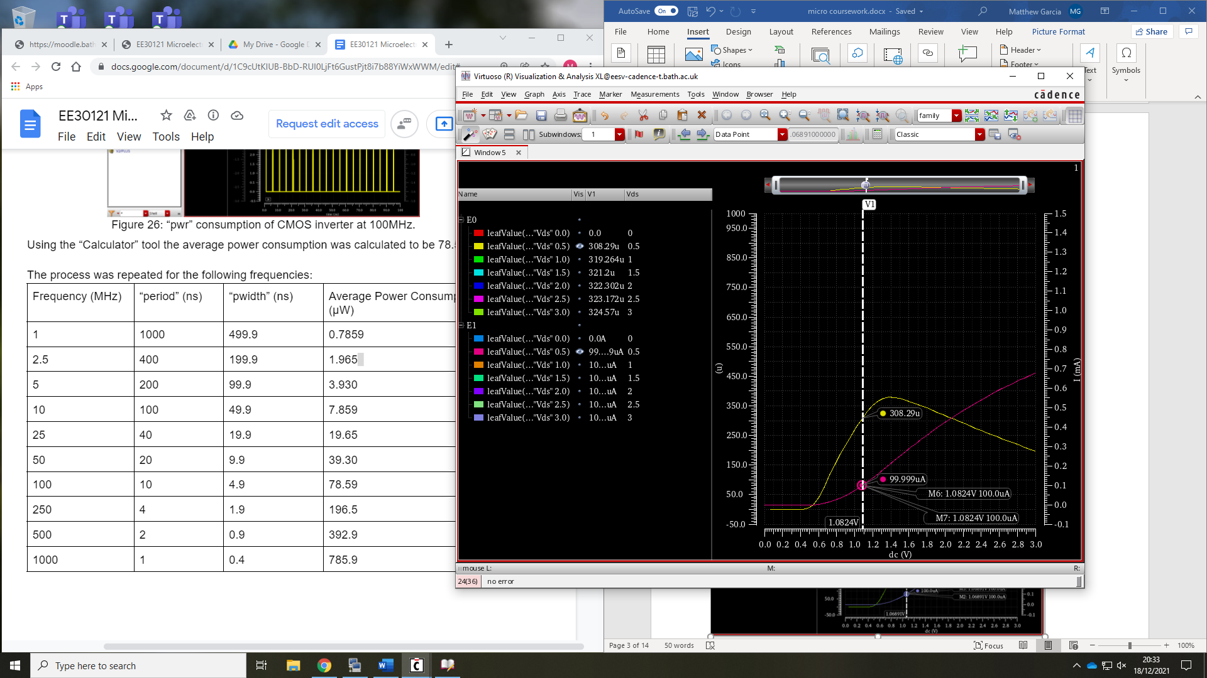

Figure 7: nmos transfer characteristics for Vds 0.5V

Therefore, the highest transconductance gain value was found at Vds = 3V with a value of 317.584 $μ$ A/V. The lowest transconductance gain value was found at Vds = 0.5V with a value of 308.29 $μ$ A/V. In order to find the overall estimate for transconductance gain an average of the highest and lowest value at 100 $μ$ giving a transconductance gain of $g_{m}=312.937μ$ A/V at 100 $μ$ A.

# Experiment 2:

## Exercise 1

For this exercise a LTP amplifier circuit in differential mode was constructed to the schematic in figure 7. Using the ADE L a DC operating point analysis was used with V2 being the selected component with a range of -1.5V to 1.5V. The pmos’s transistor drain currents were plotted in figure 8.

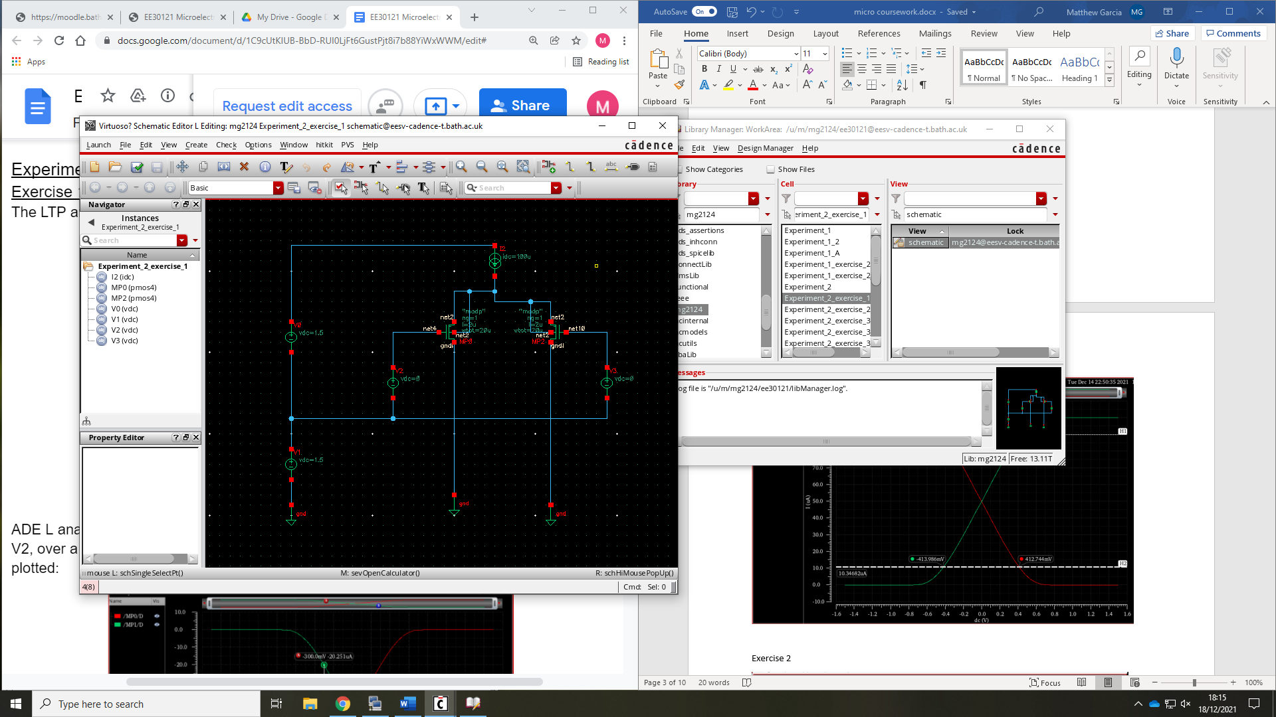

Figure 7: LTP amplifier circuit in differential mode

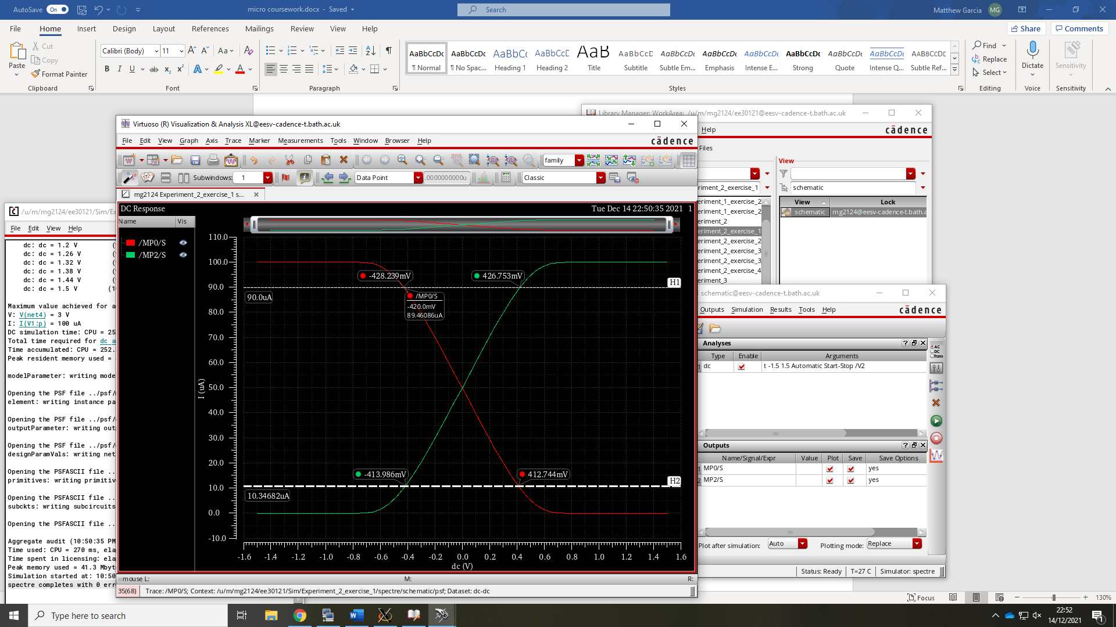

Figure 8: LTP differential mode Id vs Vg

By finding the gradient in figure 8 the transconductance gain was estimated to be 94.74 $μ$ A/V

## Exercise 2

Figure_ was constructed to simulate the LTP amplifier in common mode. Using the previous method from exercise 2, figure 9 was plotted.

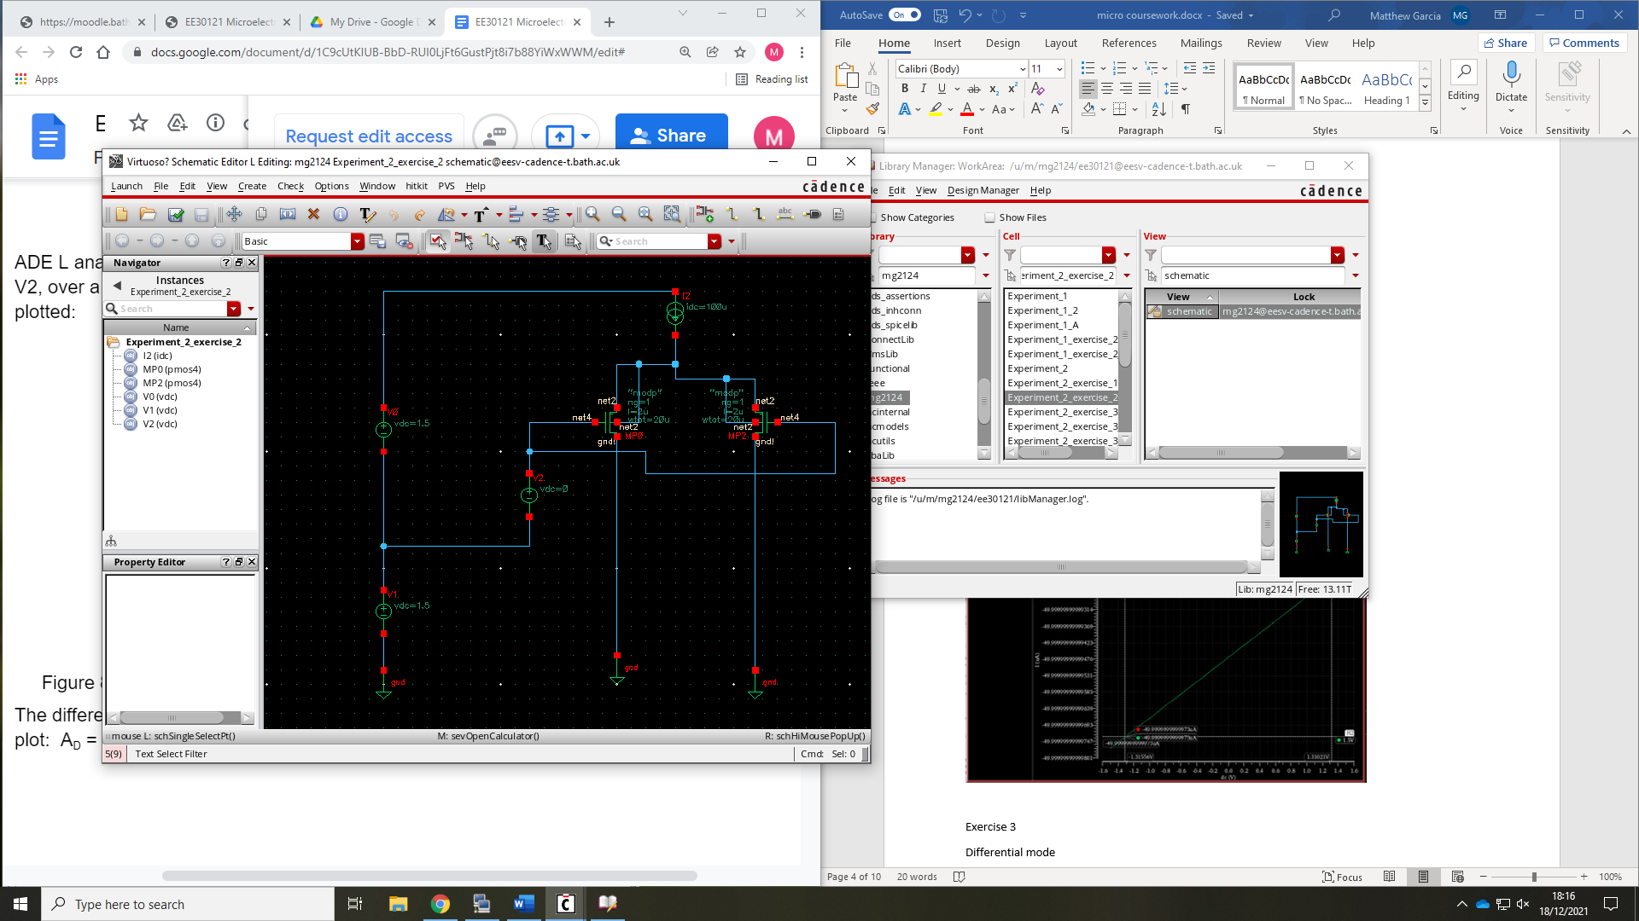

Figure 9: LTP amplifier circuit in differential mode

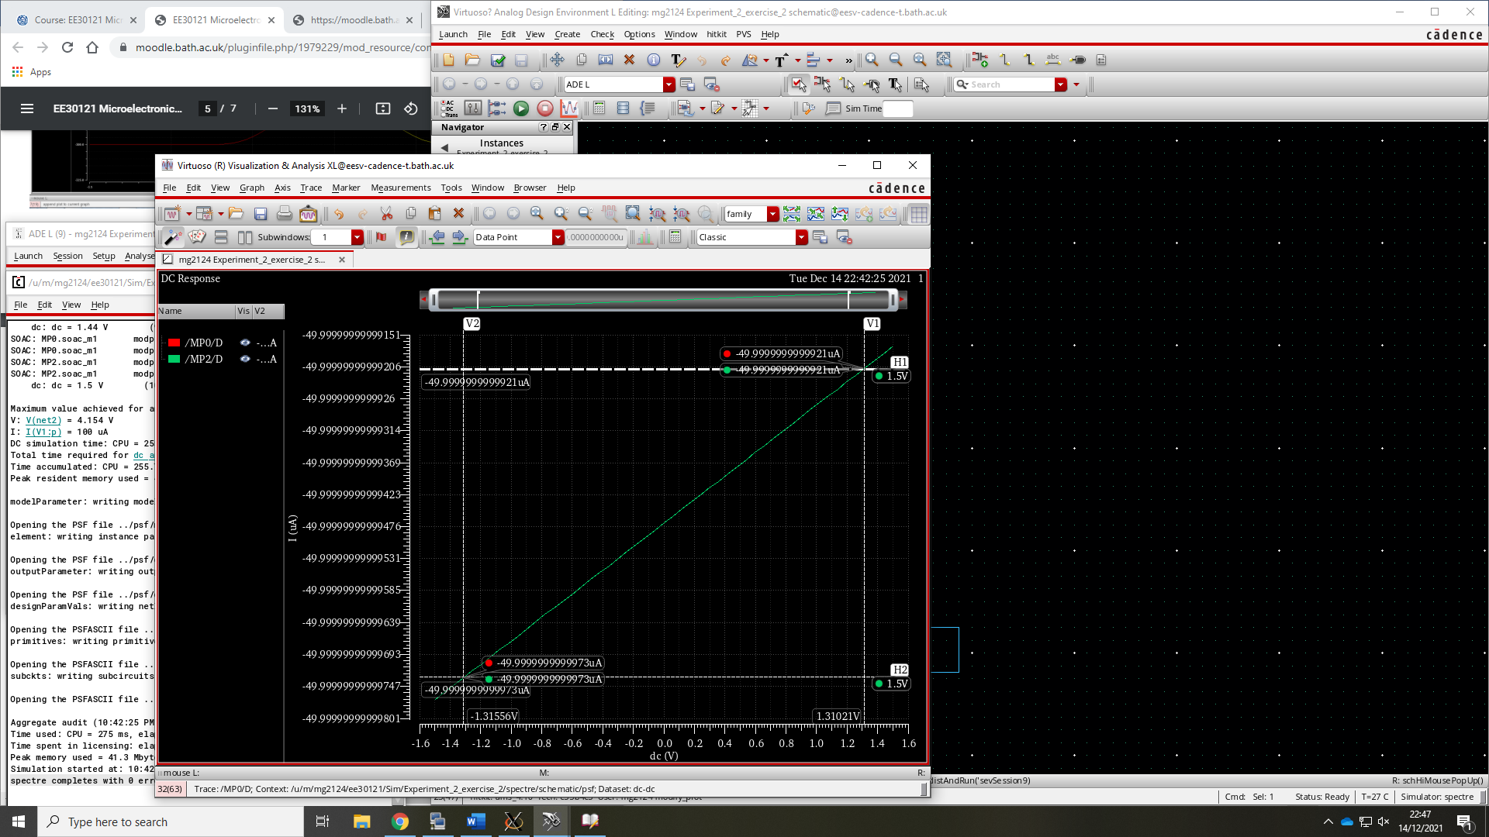

Figure 10: LTP common mode Id vs Vg

From figure 10 the gradient and therefore transconductance gain was estimated to be 1.980 $a$ A/V.

With both the transconductance gain of common mode and differential mode is known the common mode rejection ratio of the LTP amplifier is now estimated using $CMRR=20\log_{10}⁡\left(\frac{A_{D}}{A_{CM}}\right)$.

Therefore $CMRR=20\log_{10}⁡\left(\frac{94.79×{10}^{-6}}{1.992×{10}^{-18}}\right)=273.6dB$

## Exercise 3

Using the schematics from exercise 1 and 2 a DC operating mode analysis was used similar to exercise 1 and 2, but the voltage either side of the ideal current source was plotted producing figure 11 and figure 12.

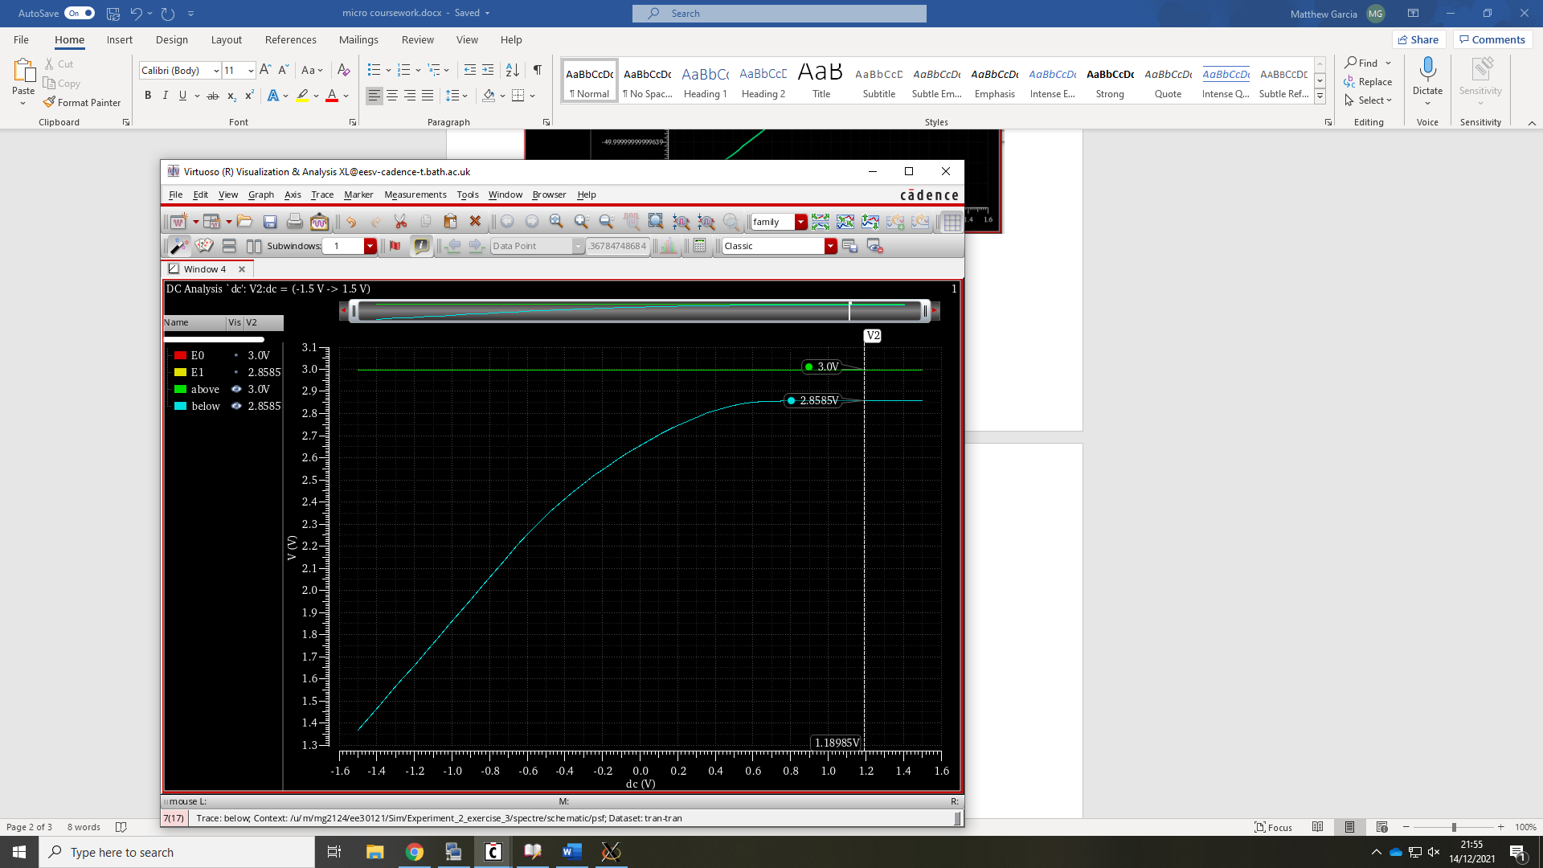

Figure 10: Voltage across current source in differential mode

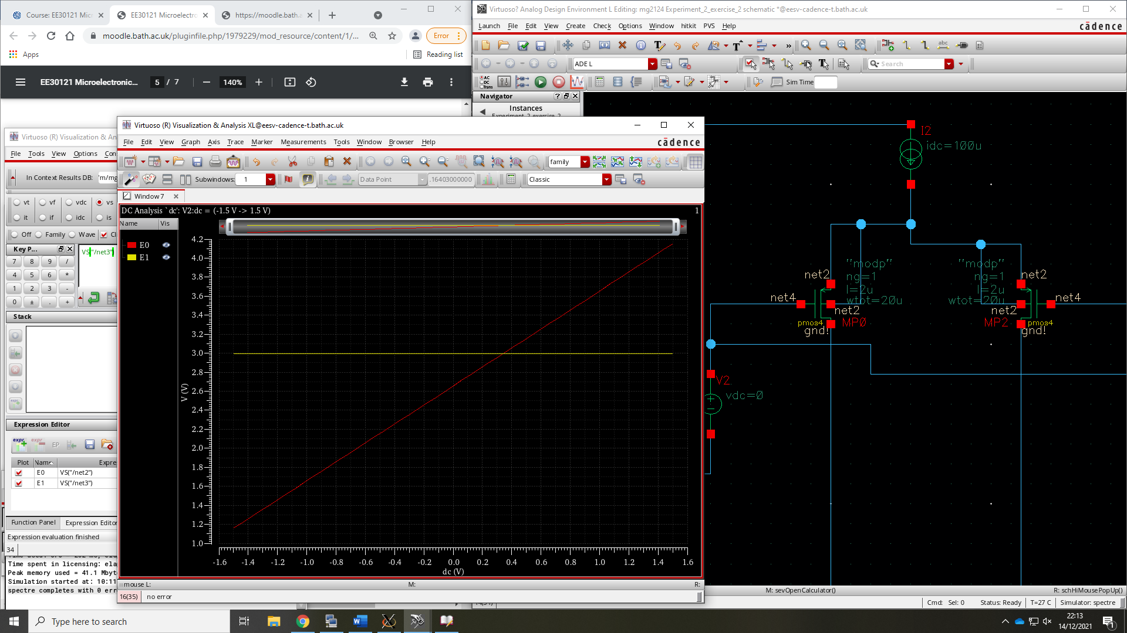

Figure 10: Voltage across current source in commom mode

To find the ideal currents source’s equivalent resistance the difference in voltage in and out of the current source was found and using Ohms law was found to be 1.415. This value of resistance was an approximate taken from the saturated section but as seen from the graph the equivalent resistance changes with the voltage supplied from V2.

Schematics seen in figure_ and figure_ was produced to simulate the equivalent resistor and was simulated using parameters of exercise 1 and exercise 2 respectively.

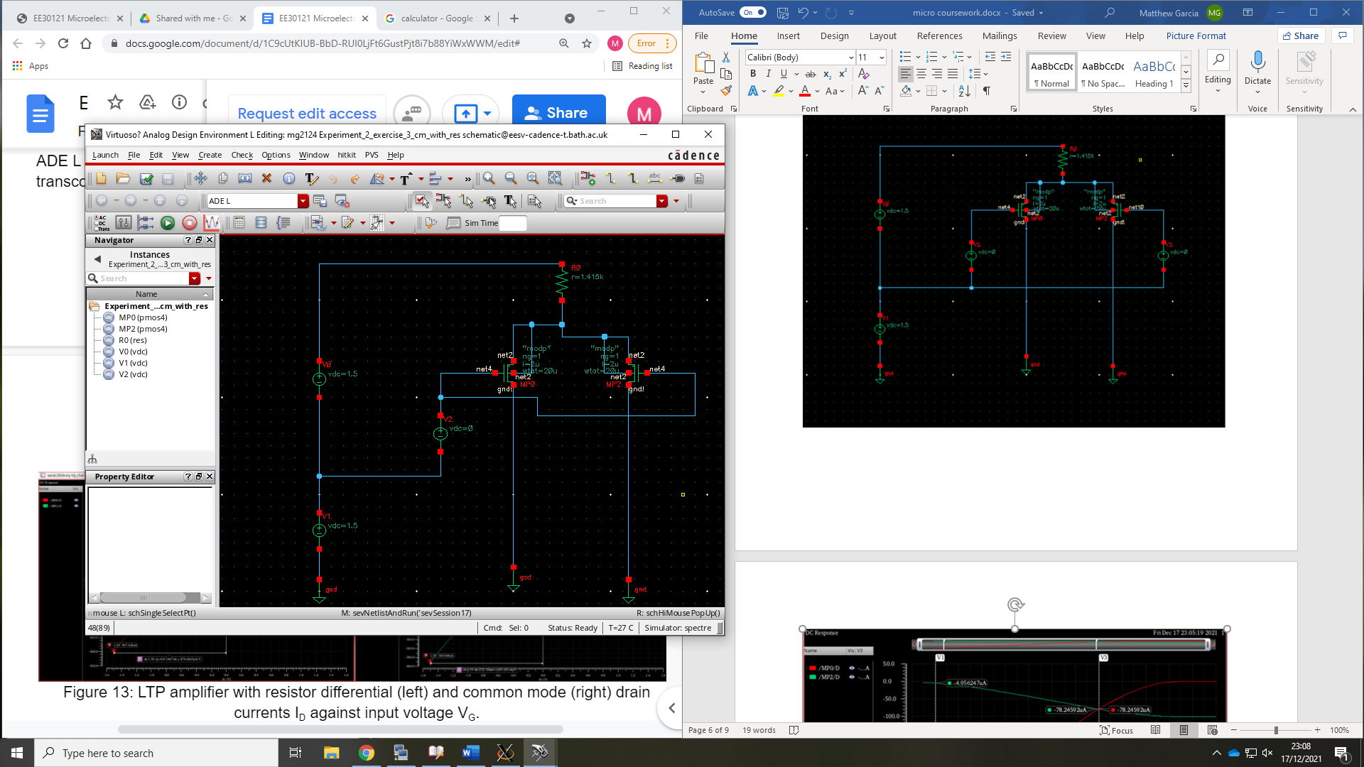

Figure 13: LTP amplifier with equivalent resistor in common mode

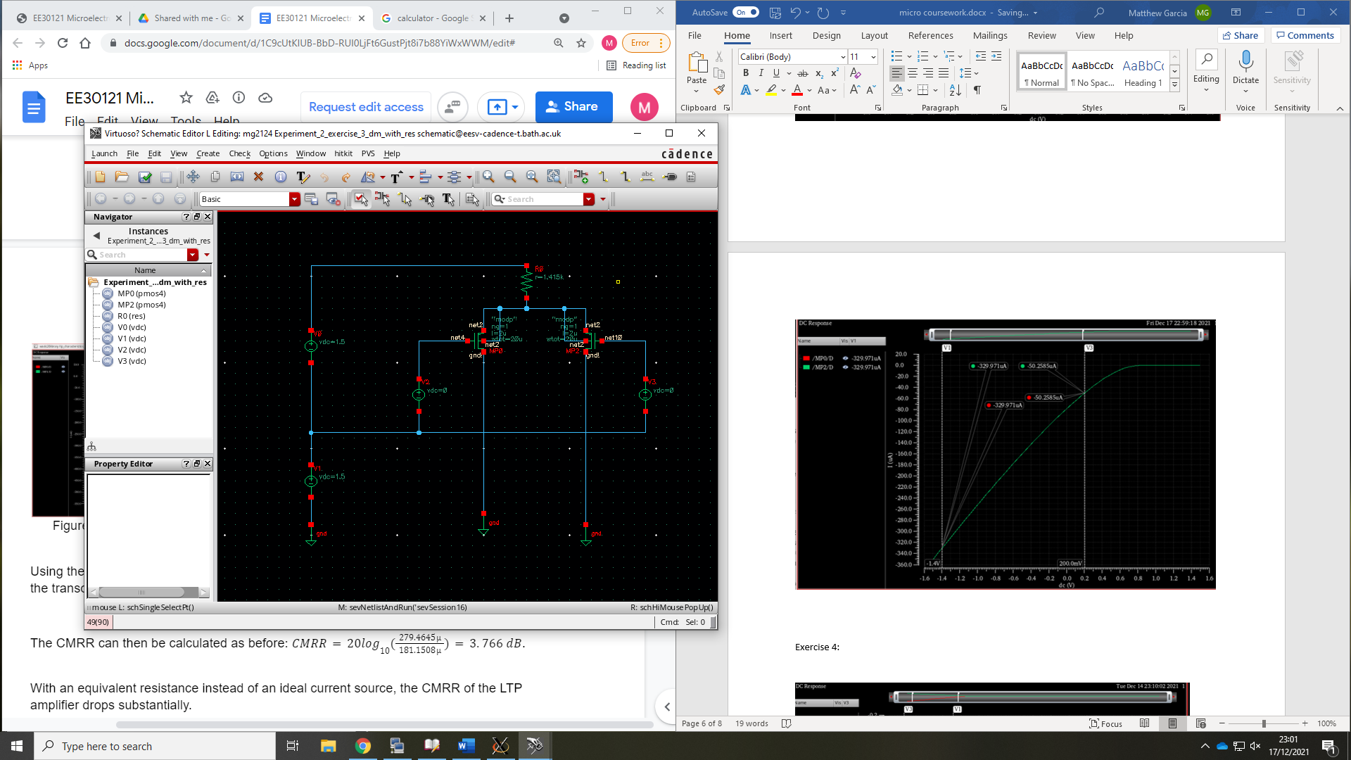

Figure 14: LTP amplifier with equivalent resistor in differential mode

From figure 15 using the gradient the transconductance gain was found to be 174.8 $μ$ A/V

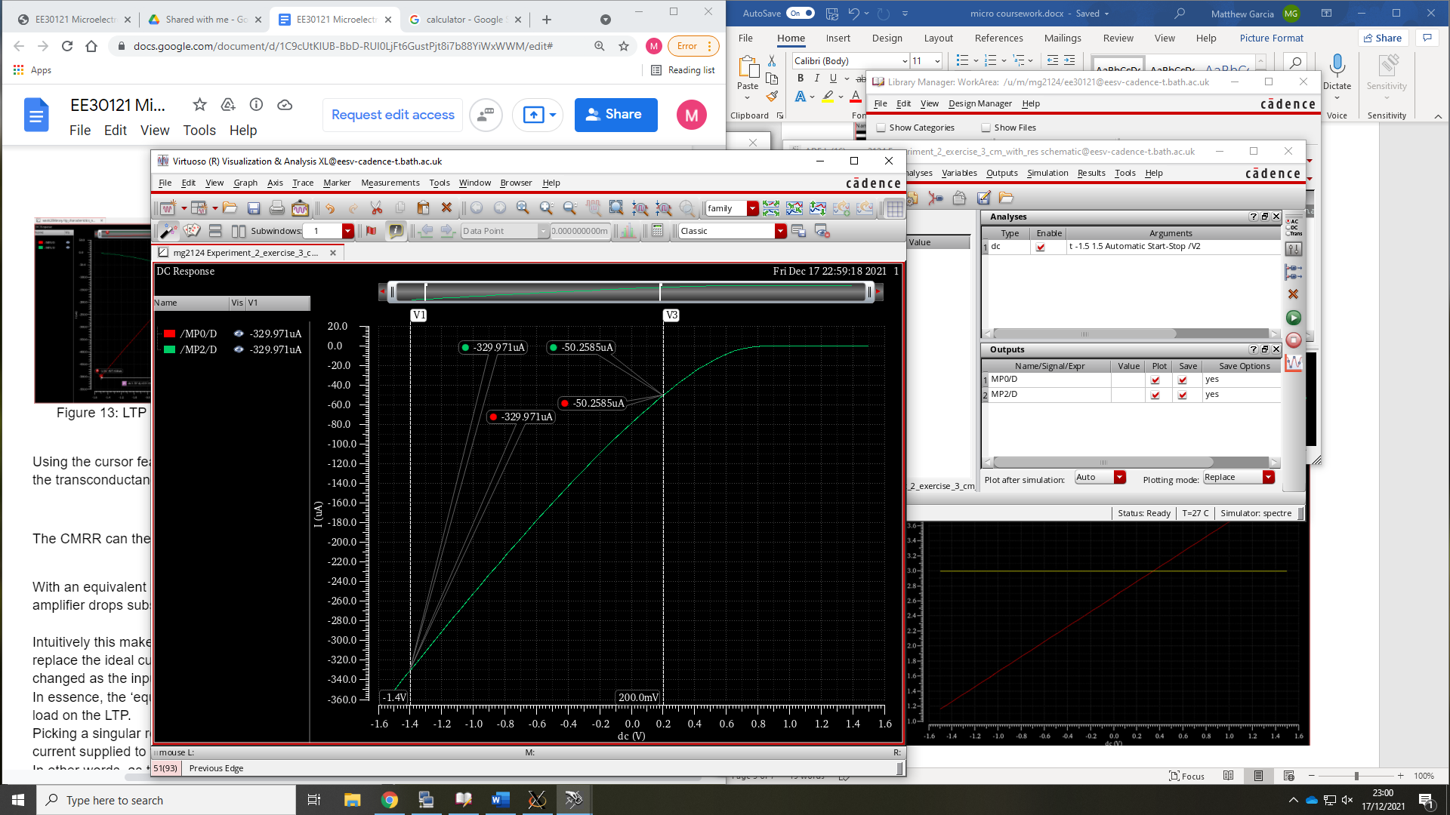

Figure 15: LTP amplifier with equivalent resistor in common mode Id vs Vg

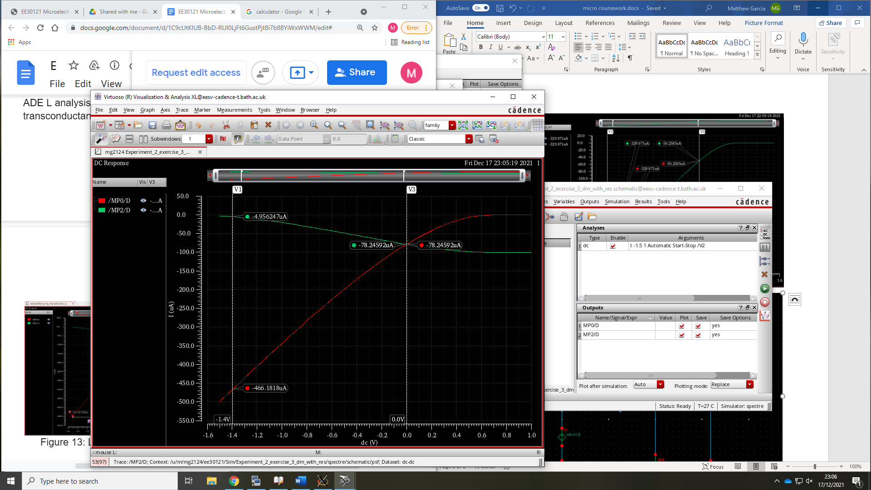

Figure 16: LTP amplifier with equivalent resistor in differential mode Id vs Vg

From figure 16 using the gradient the transconductance gain was found to be 277.1 $μ$ A/V

With both transconductance gains the CMRR was calculated using the same method as experiment 1.

Therefore $CMRR=20\log_{10}⁡\left(\frac{277.1×{10}^{-6}}{174.8×{10}^{-6}}\right)=4.001dB$

As seen in the calculated CMRR values when the ideal current source sis switched to the equivalent resistor the CMRR significantly decreases. This is expected as seen in exercise 1 and 2 shows that the resistance changes with input to the LTP and the resistance does not stay the same. By picking a set resistance this will change the current supplied to the system and therefore the CMRR will also be lowered.

## Exercise 4:

Figure 17 and figure 19 was constructed using a current mirror with the equivalent resistor calculated in exercise 1 and 2. These schematics were DC operating point simulated just like in exercise 1 and two producing figure 19 and figure 20

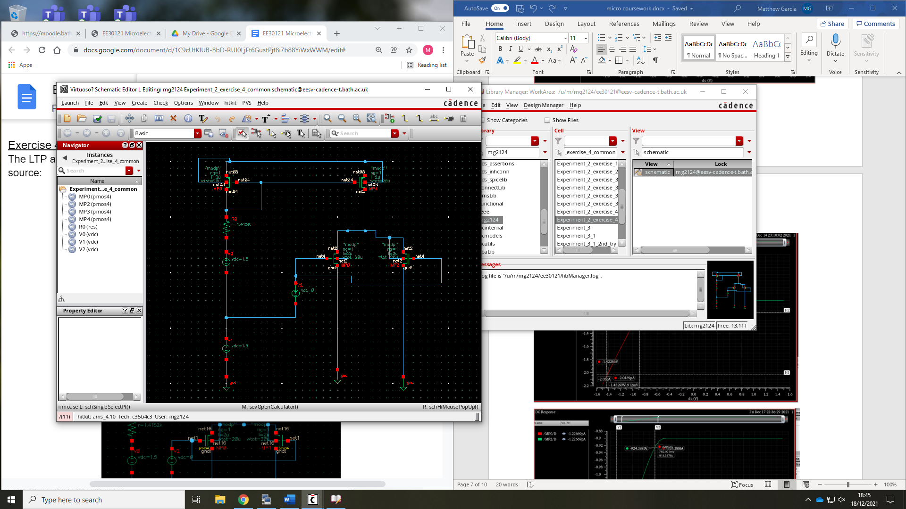

Figure 17: LTP amplifier with equivalent resistor in common mode circuit

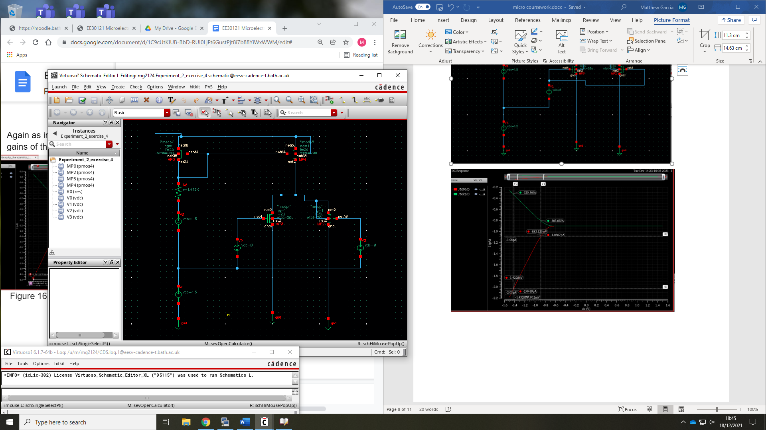

Figure 18: LTP amplifier with equivalent resistor in common mode circuit

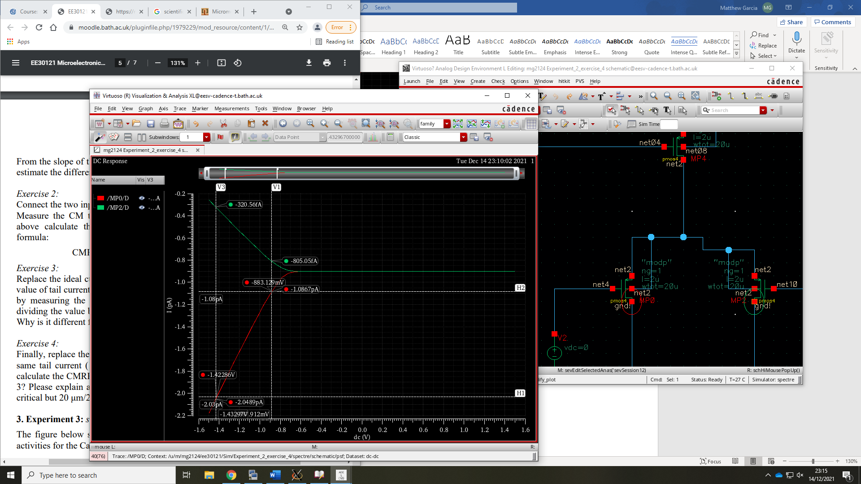

Figure 19: LTP amplifier with current mirror in differential mode Id vs Vg

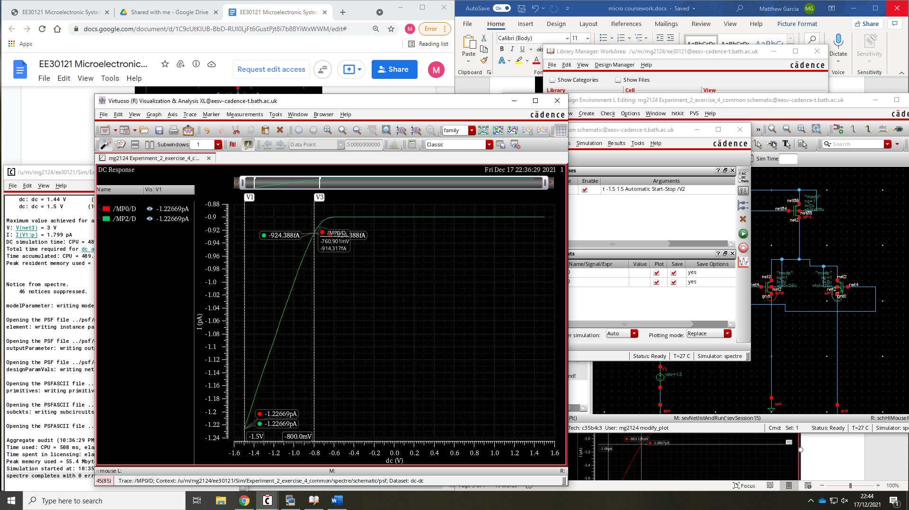

Figure 20: LTP amplifier with current mirror in common mode Id vs Vg

From figure 19 and figure 20 the gradient was calculated and gave the transductance gains of

$$A_{CM}=432.2fAV \text{and} A_{D}=1.764pA/V$$

Therefore $CMRR=20\log_{10}\left(\frac{1.764×{10}^{-12}}{432.2×{10}^{-15}}\right)=12.22dB$

By comparing the CMRR values of the simulations of the ideal, equivalent resistor, and current mirror. The ideal current source produces the highest CMRR by a significant amount (as it is ideal). The second highest was the current mirror and the lowest the resistor. This is expected as the current mirror allows for the supply of constant current that is independent of the voltage across it. The equivalent resistor does not.

# Experiment 3:

## Exercise 1:

Figure 21 and figure 22 was constructed with the pulse generator setting of:

|  |  |
| --- | --- |
| Voltage 1 | 0V |
| Voltage 2 | 3.3 |
| Period | 10ns |
| Delay time | 0s |
| Rise time | 100p |
| Fall time | 100p |
| Pulse width | 4.9ns |

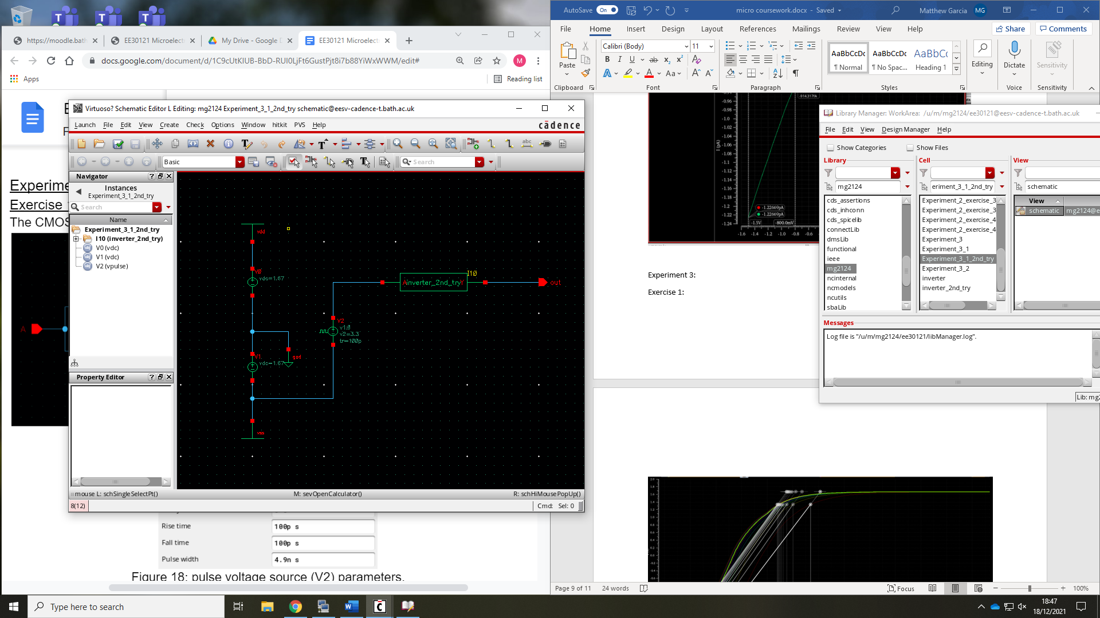

Figure 21: inverter testbench circuit

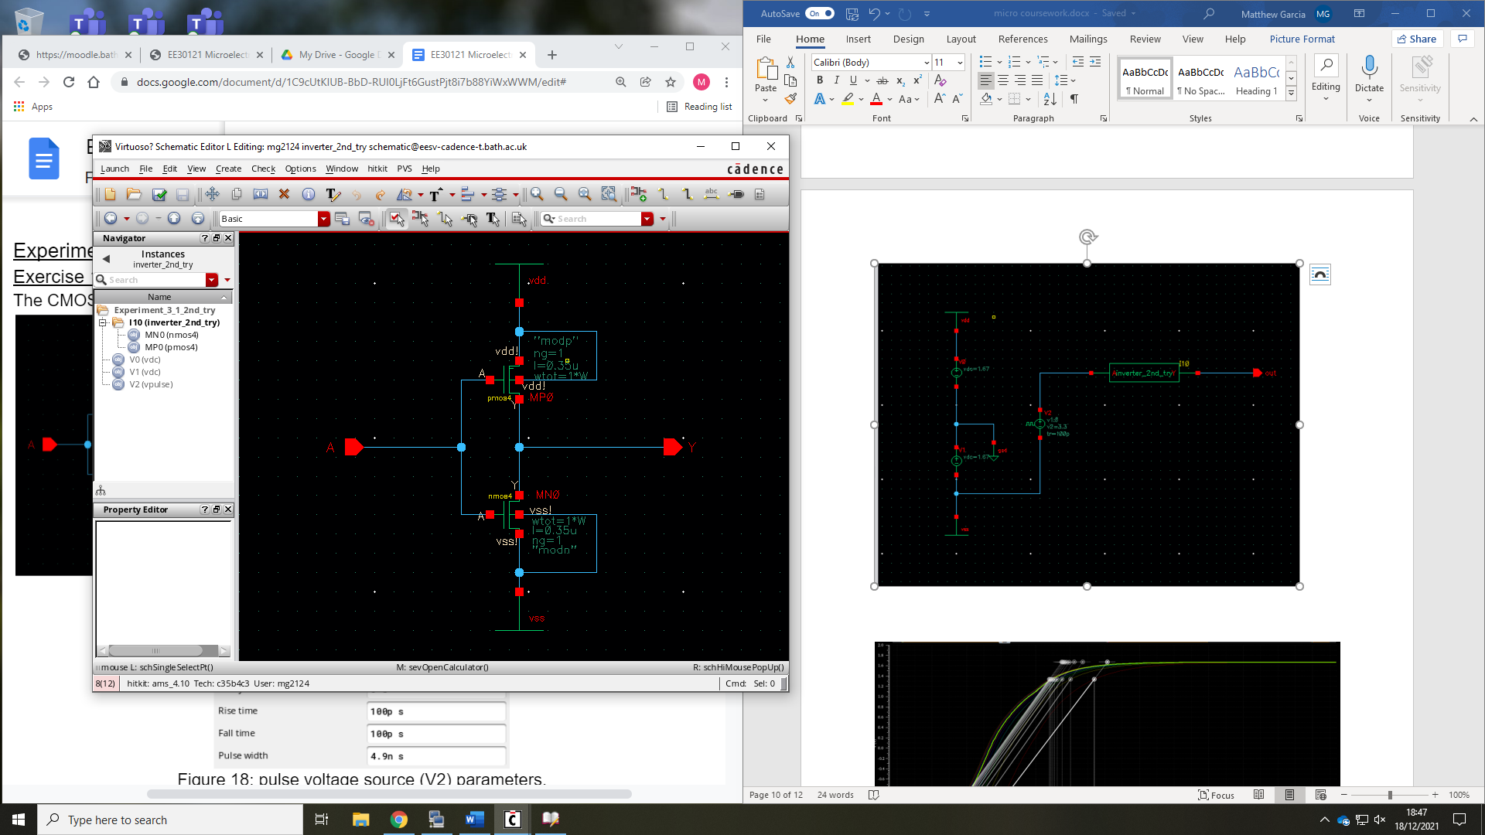

Figure 22: CMOS inverter

A transient analysis was done with a stop time of 30ns with an output of Y. A parametric sweep of the pmos width Wp in range 10 $μ$ to 100 $μ$ with a step size of $10μ$ this was plotted in figure 23. Using the edge mode the 10% to 90% rise and fall time was found and compared.

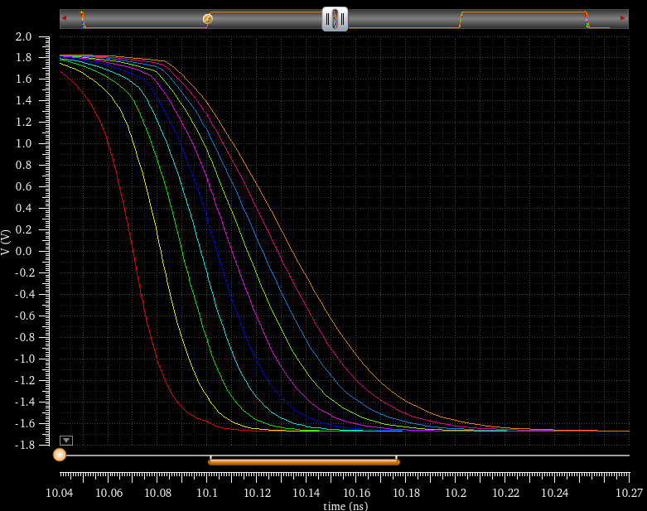

Figure 23: inverter rise and fall plots for transient analysis of Voltage out of inverter

|  |  |  |  |
| --- | --- | --- | --- |
|  | rise | fall | difference |
| 100u | 57.55 | 75.06 | 17.51 |
| 90u | 57.36 | 68.85 | 11.49 |
| 80u | 57.18 | 62.99 | 5.81 |
| 70u | 56.96 | 57.24 | 0.28 |
| 60u | 56.68 | 51.78 | -4.9 |
| 50u | 56.54 | 46.61 | -9.93 |
| 40u | 56.13 | 41.79 | -14.34 |
| 30u | 56.11 | 37.54 | -18.57 |
| 20u | 56.14 | 34.99 | -21.15 |
| 10u | 60.54 | 32.06 | -28.48 |

from the table above the next simulation was used between 60 $μm$ to 70 $μm$ with a step size of 1 $μ$ as 70 $μ$ giving a homogenous rise fall time at 69.5 $μm$ as seen in figure_24.

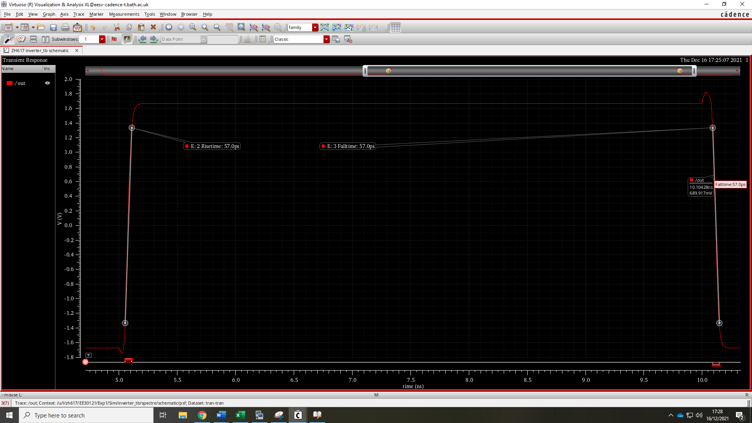

Figure 24: voltage plot of inverter at Wp of 69.5 $μm$

Therefore, a Wp=69.5 $μ,$ Lp=*350 $nm$, Wn=100 $μ$, lp=350nm gives a rise/fall time of 57.0ps*

## Exercise2:

From Shichman-Hodge equation it is known that $I_{D}∝\frac{W}{L}$. Therefore, to get the fast switching times you must reduce L or increase W. As the mosfet lengths are currently at their realistic minimum of 350nm. Therefore, if W of the mosfets is increased the rise and fall time should decrease**.** This was simulated from 1 $μm$*to 10,000 $μm$* and produces figure 26.

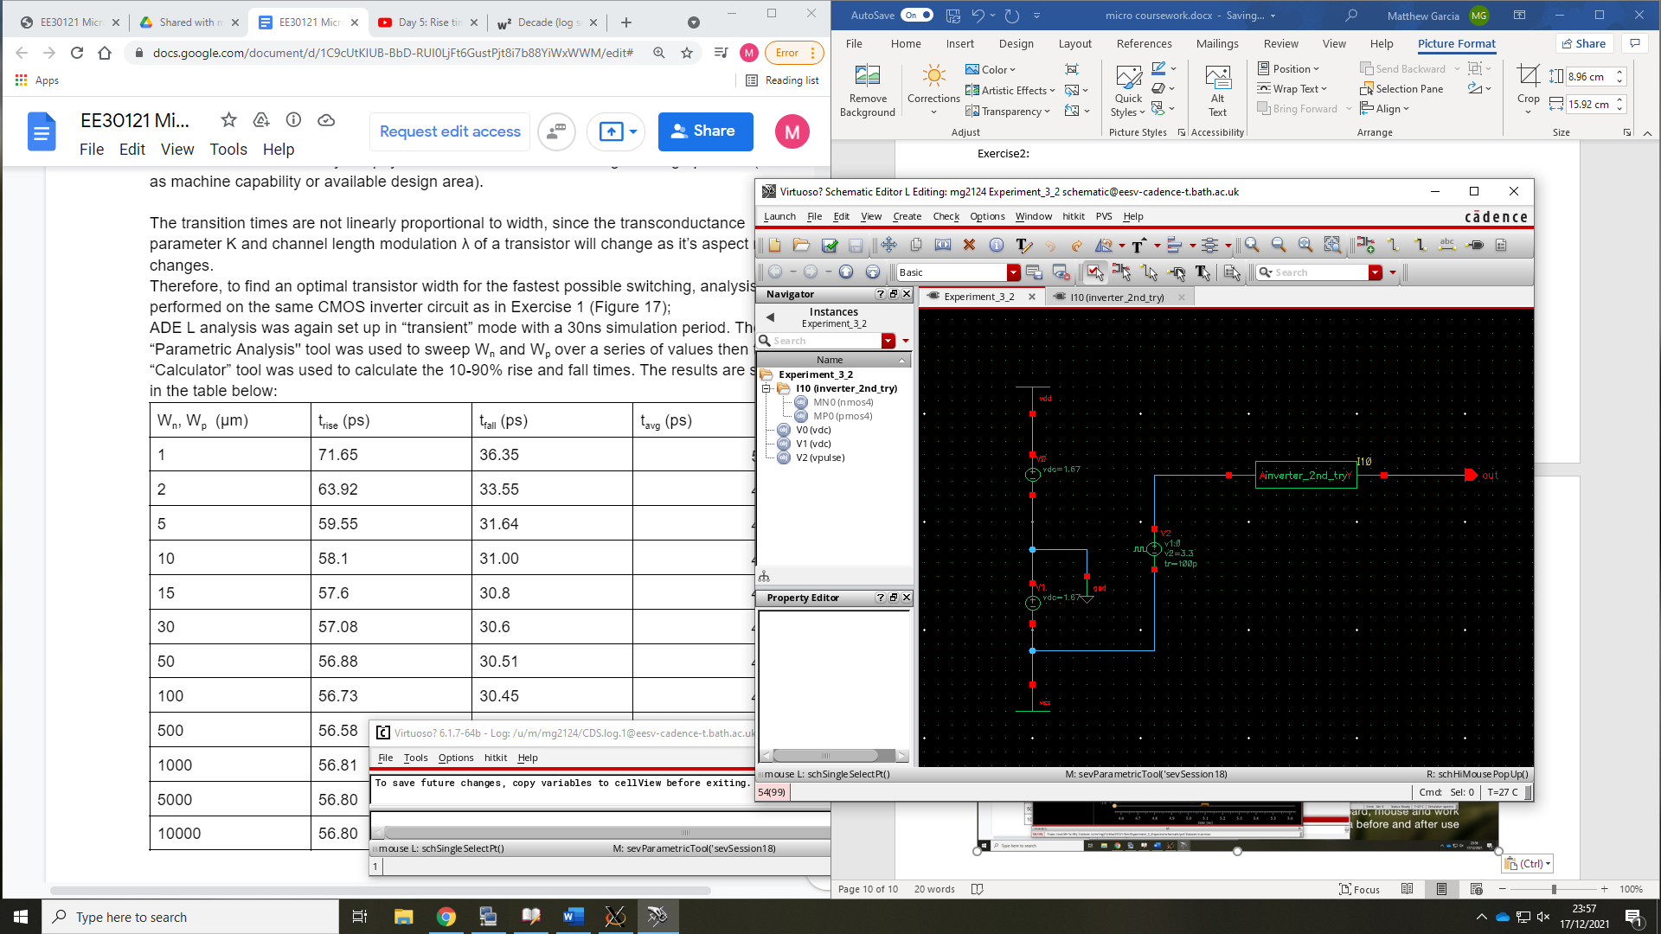

Figure 25: inverter test bench circuit

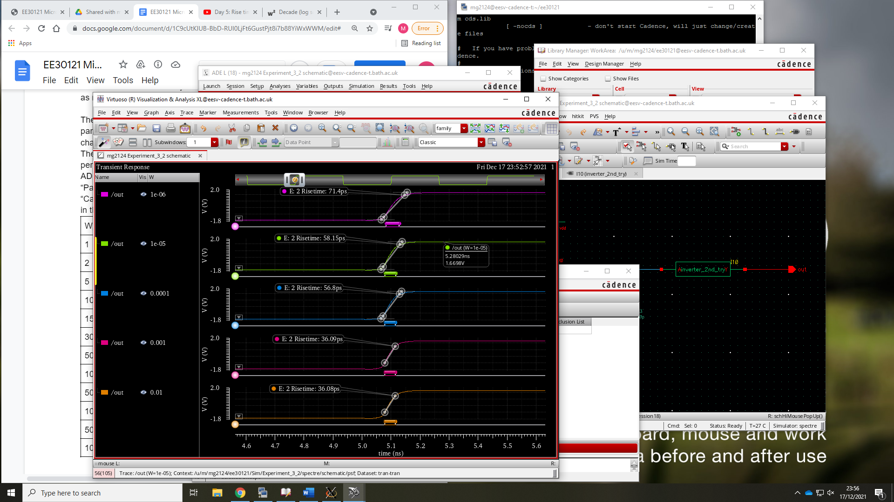

Figure 2**6: transient voltage plot for varying mosfet width values**

From figure 26 the best realistic value would be 500 $μ$*m*

## Exercise 3:

Using schematic from figure_ the power consumption of the system was plotted using a transient analysis with a stop time of 10ns at a frequency of 1 MHz producing fig_.

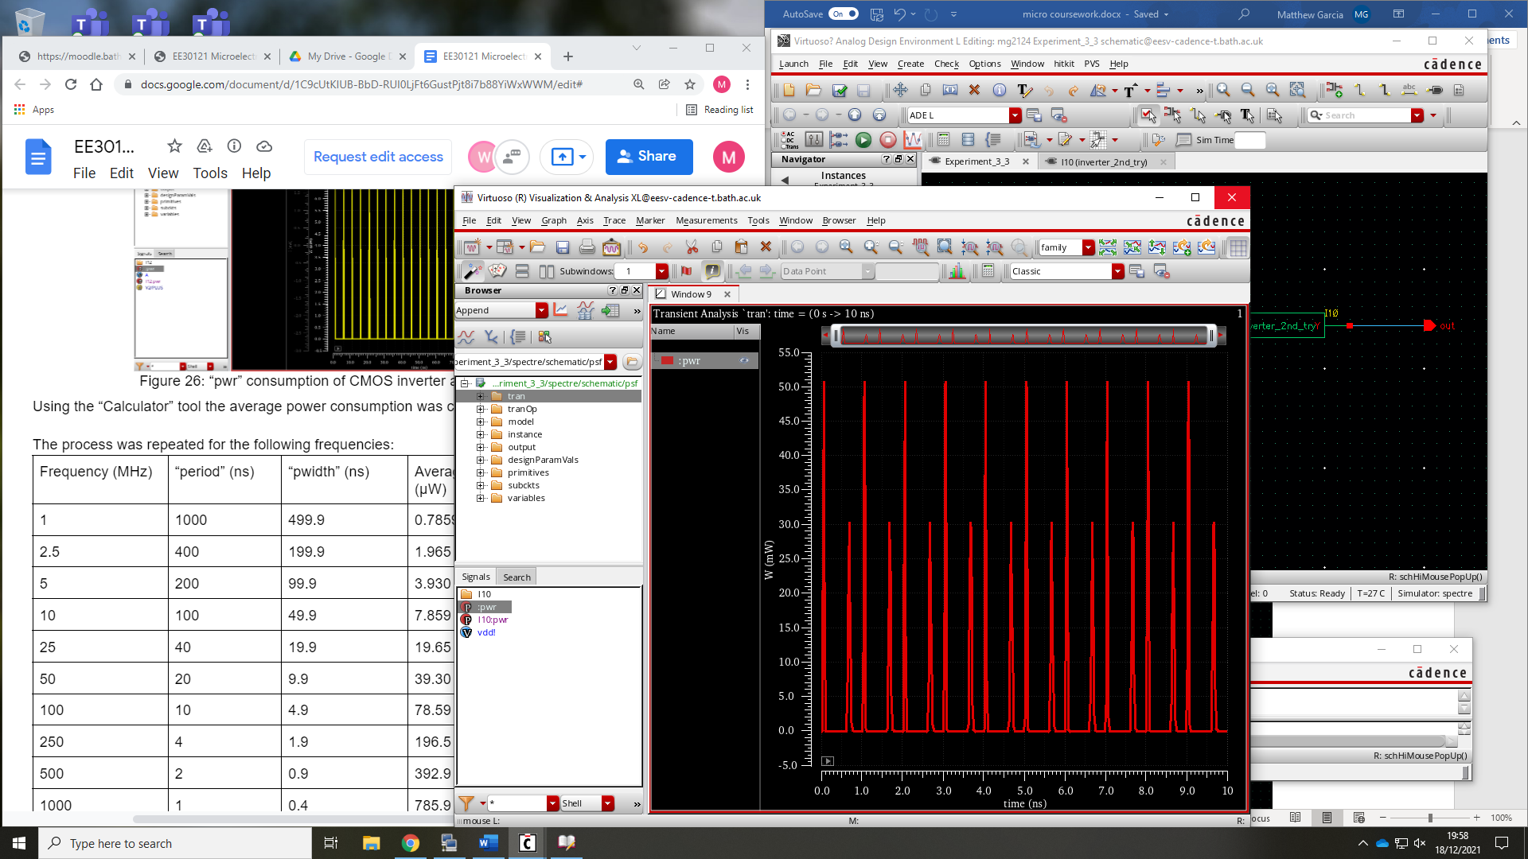

Figure 27: pwr anlaysis of inverter test bench schematic at 1MHz

This process was repeated, and the pulse generators values were updated with the frequency to produce the table below

|  |  |
| --- | --- |
| Frequency (mhZ) | average power (µW) |
| 1 | 3.371E-3 |
| 5 | 674.3E-6 |
| 10 | 337.1E-6 |
| 50 | 67.42E-6 |
| 100 | 33.71E-6 |
| 500 | 6.742E-6 |
| 1000 | 3.371E-6 |

The table demonstrates the linear relationship between frequency and power consumption which is intuitively correct as the higher the switching frequency is the larger number of high/low state changes are occurring causing a higher average power consumption. This is an ideal measurement taken at room temperature and would likely have a larger actual power consumption than in the table above.